**SQL Project on Online Book store**

3 CSV Files Tables must have at least one common column with same column name and same data type Books.csv , Customers.csv and Orders.csv

* **Basic Queries**

1. Retrieve all books in the "Fiction" genre

SELECT *

FROM Books

WHERE Genre = 'Fiction';

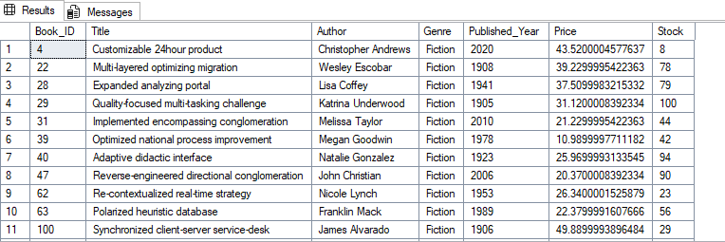

1. Find books published after the year 1950

SELECT *

FROM Books

WHERE Published_Year > 1950;

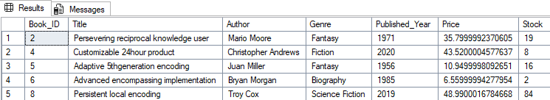

1. List all customers from the Canada.

SELECT *

FROM Customers

WHERE Country = 'Canada';

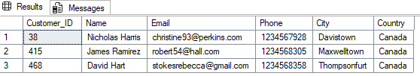

1. Show orders placed in November 2023.

SELECT *

FROM Orders

WHERE Order_Date BETWEEN '2023-09-01' AND '2023-09-30';

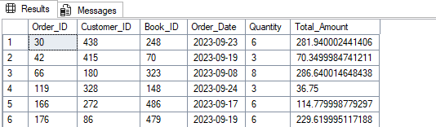

1. Retrieve the total stock of books available.

SELECT SUM(Stock) AS total_stock

FROM Books;

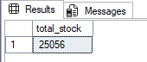

1. Find the details of the most expensive book.

SELECT TOP 1 *

FROM Books

ORDER BY Price DESC;



1. Show all customers who ordered more than 1 quantity of a book.

SELECT *

FROM Orders

WHERE Quantity > 1;

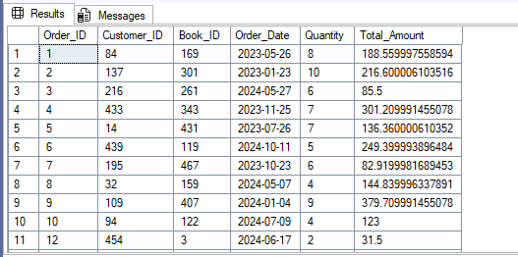

1. Retrieve all orders where the total amount exceeds $20.

SELECT *

FROM Orders

WHERE Total_Amount > 20;

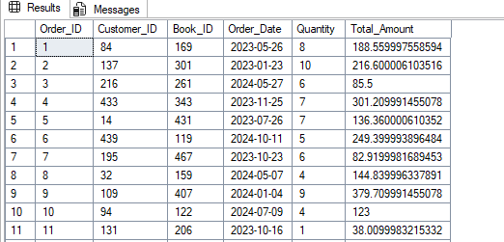

1. List all genres available in the Books table.

SELECT DISTINCT Genre

FROM Books;

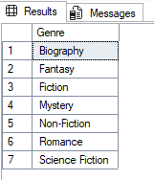

1. Find the book with the lowest stock.

SELECT TOP 1 *

FROM Books

ORDER BY Stock ASC;

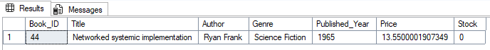

1. Calculate the total revenue generated from all orders.

SELECT ROUND(SUM(Total_Amount),2)

FROM Orders;

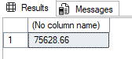

* **Advanced Queries**

1. Retrieve the total number of books sold for each genre.

SELECT b.Genre,SUM(o.Quantity) AS total_sold_book

FROM Books AS b

JOIN Orders AS o

ON b.Book_Id = o.Book_Id

GROUP BY b.Genre;

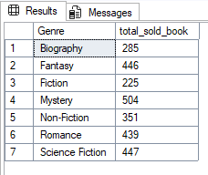

1. Find the average price of books in the "Fantasy" genre.

SELECT AVG(Price) AS average_books

FROM Books

WHERE Genre = 'Fantasy';

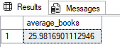

1. List customers who have placed at least 2 orders.

SELECT c.Name,COUNT(c.Customer_ID)

FROM Customers AS c

INNER JOIN Orders AS o

ON c.Customer_ID = o.Customer_ID

GROUP BY c.Name

HAVING COUNT(c.Customer_ID) >= 2;

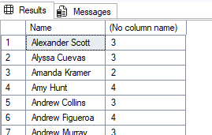

1. Show the top 3 most expensive books of 'Fantasy' Genre.

SELECT TOP 3 *

FROM Books

WHERE Genre = 'Fantasy'

ORDER BY Price DESC;

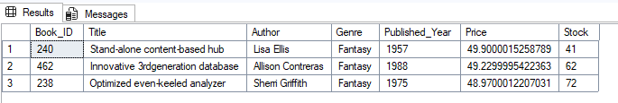

1. Retrieve the total quantity of books sold by each author.

SELECT b.Author,SUM(o.Quantity) AS sum_of_quantity

FROM Books AS b

JOIN Orders AS o

ON b.Book_ID = o.Book_ID

GROUP BY b.Author ;

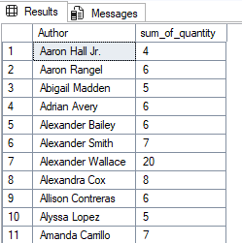

1. List the cities where customers who spent over $30 are located.

SELECT c.City,o.Total_Amount

FROM Customers c

JOIN Orders o

ON c.Customer_ID = o.Customer_ID

WHERE o.Total_Amount > 30

ORDER BY o.Total_Amount DESC;

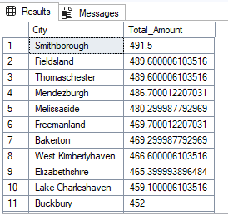

1. Find the customer who spent the most on orders.

SELECT TOP 1 c.NAME,ROUND(SUM(o.Total_Amount),2)

FROM Customers c

JOIN Orders o

ON c.Customer_ID = o.Customer_ID

GROUP BY c.Name

ORDER BY SUM(o.Total_Amount) DESC;

